**CHEF**

1) What is Chef?

Chef is a powerful automation platform that transforms complex infrastructure into code, bringing your servers and services to life. Whether you’re operating in the cloud, on-premises, or a hybrid, Chef automates how applications are configured, deployed, and managed across your network, no matter its size.

Chef is built around simple concepts: achieving desired state, centralized modelling of IT infrastructure, and resource primitives that serve as building blocks. These concepts enable you to quickly manage any infrastructure with Chef. These very same concepts allow Chef to handle the most difficult infrastructure challenges on the planet. Anything that can run the chef-client can be managed by Chef.

2) What is a resource?

A resource represents a piece of infrastructure and its desired state, such as a package that should be installed, a service that should be running, or a file that should be generated.

3) Define following terms in 1-2 sentences:

Recipes

A recipe is a collection of resources that describes a particular configuration or policy. A recipe describes everything that is required to configure part of a system. Recipes do things such as:

* Install and configure software components
* Manage files
* Deploy applications
* Execute other recipes

Cookbooks:

A cookbook is the fundamental unit of configuration and policy distribution. A cookbook defines a scenario and contains everything that is required to support that scenario:

* Recipes that specify the resources to use and the order in which they are to be applied
* Attribute values
* File distributions
* Templates
* Extensions to Chef, such as libraries, definitions, and custom resource

Chef-client

A chef-client is installed on every node that is under management by Chef. The chef-client performs all of the configuration tasks that are specified by the run-list and will pull down any required configuration data from the Chef server as it is needed during the chef-client run.

A **node** is any machine—physical, virtual, cloud, network device, etc.—that is under management by Chef.

Chef-server

The Chef server acts as a hub of information. Cookbooks and policy settings are uploaded to the Chef server by users from workstations. (Policy settings may also be maintained from the Chef server itself, via the Chef management console web user interface.)

The chef-client accesses the Chef server from the node on which it’s installed to get configuration data, perform searches of historical chef-client run data, and then pull down the necessary configuration data. After the chef-client run is finished, the chef-client uploads updated run data to the Chef server (as the updated node object), uploads data generated by audit-mode (for additional rules processing by Chef Analytics), and generates reporting data.

Chef management console is the user interface for the Chef server. It is used to manage data bags, attributes, run-lists, roles, environments, and cookbooks, and also to configure role-based access for users and groups.

Convergence Run

Convergence is when the configuration management system brings the node into compliance with policy.

In other words, the node is configured based on the roles and recipes in its run list.

Convergence in Chef happens in two phases.

* Compile
* Execute

Configuration Drift

**Configuration Drift** is the phenomenon where running servers in an infrastructure become more and more different as time goes on, due to manual ad-hoc changes and updates, and general entropy.

Attributes

An attribute can be defined in a cookbook (or a recipe) and then used to override the default settings on a node. When a cookbook is loaded during a chef-client run, these attributes are compared to the attributes that are already present on the node. Attributes that are defined in attribute files are first loaded according to cookbook order. For each cookbook, attributes in the default.rb file are loaded first, and then additional attribute files (if present) are loaded in lexical sort order. When the cookbook attributes take precedence over the default attributes, the chef-client will apply those new settings and values during the chef-client run on the node.

Resources

A resource is a statement of configuration policy that:

* Describes the desired state for a configuration item
* Declares the steps needed to bring that item to the desired state
* Specifies a resource type—such as package, template, or service
* Lists additional details (also known as resource properties), as necessary
* Are grouped into recipes, which describe working configurations

Data Bags

A data bag is a global variable that is stored as JSON data and is accessible from a Chef server. A data bag is indexed for searching and can be loaded by a recipe or accessed during a search.

client.rb

A client.rb file is used to specify the configuration details for the chef-client.

* This file is loaded every time this executable is run
* On UNIX- and Linux-based machines, the default location for this file is /etc/chef/client.rb; on Microsoft Windows machines, the default location for this file is C:\chef\client.rb; use the --config option from the command line to change this location
* This file is not created by default
* When a client.rb file is present in the default location, the settings contained within that client.rb file will override the default configuration settings

Ohai

Ohai is a tool that is used to detect attributes on a node, and then provide these attributes to the chef-client at the start of every chef-client run. Ohai is required by the chef-client and must be present on a node. (Ohai is installed on a node as part of the chef-client install process.)

The types of attributes Ohai collects include (but are not limited to):

* Platform details
* Network usage
* Memory usage
* CPU data
* Kernel data
* Host names
* Fully qualified domain names
* Other configuration details

Attributes that are collected by Ohai are automatic attributes, in that these attributes are used by the chef-client to ensure that these attributes remain unchanged after the chef-client is done configuring the node.

Node Object

Attributes are stored in node object

Chef Commands:

1. Create folder structure for cookbooks

Mkdir cookbooks

Cd cookbooks

1. Create cookbook command

$chef generate cookbook learn_chef_httpd

1. Tree –shows the tree structure of all cookbooks
2. Cookbook folder structure

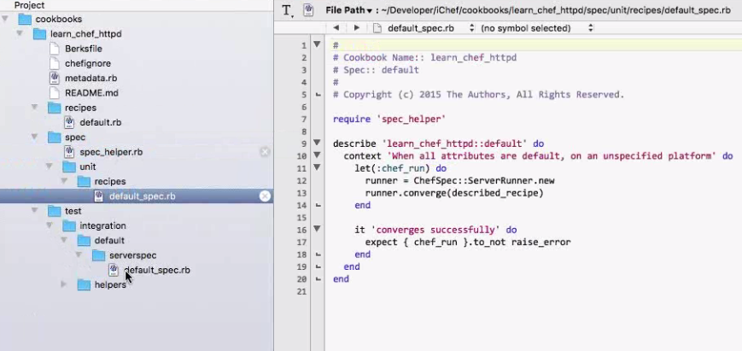

1. Contents inside of the cookbook[learn_chef_httpd]:
2. Berksfile - Used to manage the dependencies of recipes [as certain cookbooks depends on other cookbooks].

Exp: Install Nginix without installing ruby, keywork ‘required’ for installing the content

1. Chefignore - Used to mention all the recipe file
2. Metadata -

Recipes - default.rb is the default recipe

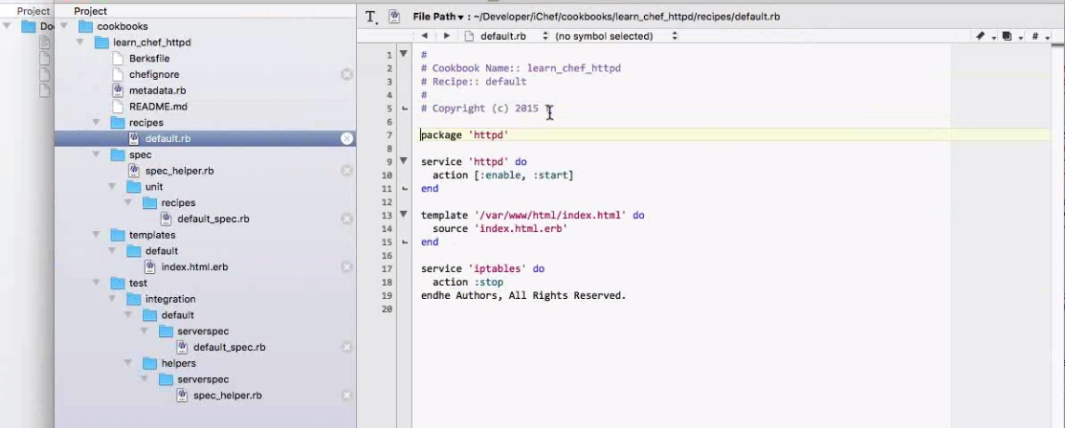

Spec - It has some recipes for unit testing

Test- Serverspec - Provides server spec default recipe for Integration testing

1. Copy/Generate Template in recipes , where in it is useful for reutilization of

$chef generate template learn_chef_httpd

1. Run the Cookbook

$sudo chef-client –local –mode- runlist [‘recipe[learn_chef_httpd]

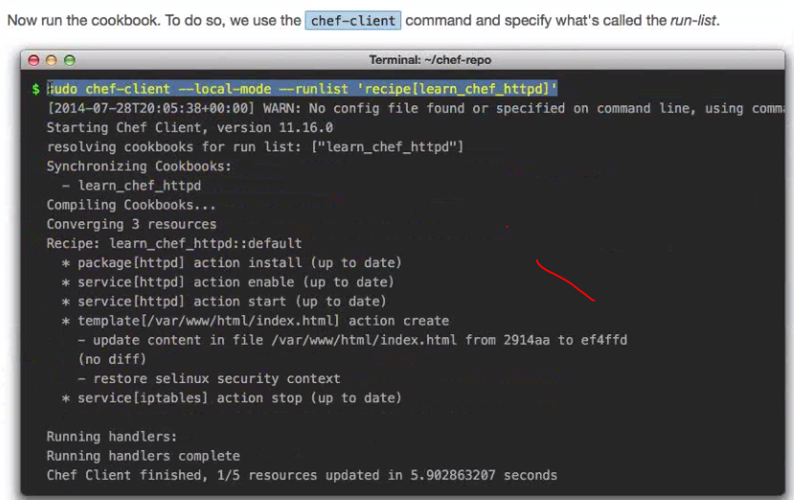

1. Curl localhost

How do I send a header to my Web server (such as Nginx / Lighttpd / Apache / ISS) on a Apple OS X or Unix or Linux based system using a curl command line option for testing and debugging my web apps or server nodes behind a load balancer?  
  
  
The curl command supports -H or --header option to pass extra HTTP header to use when getting a web page from your web server

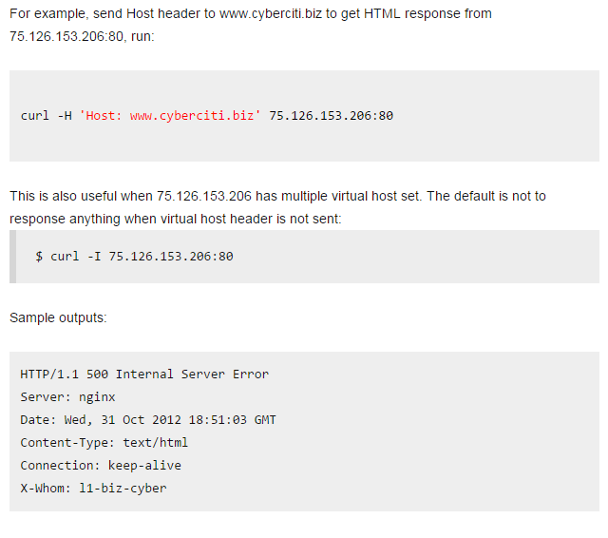

1. Difference between Chef-apply and Chef-client, also what is Run-list:

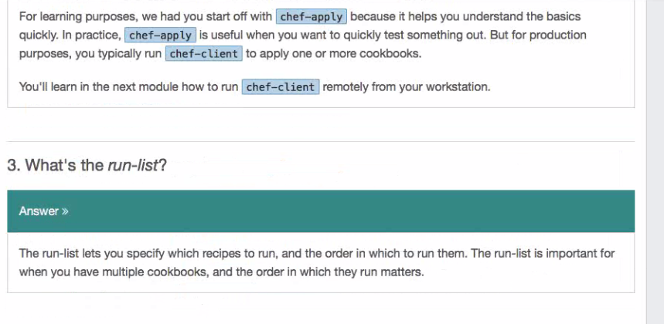

**Manage a Node**

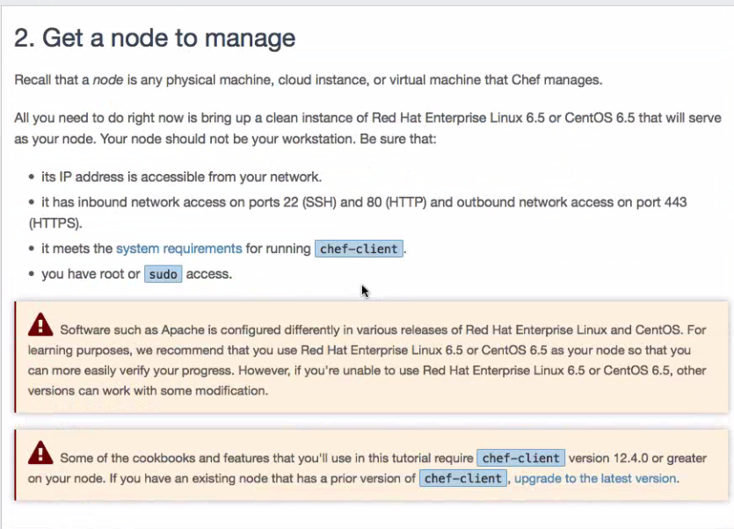

Get Hosted Chef account

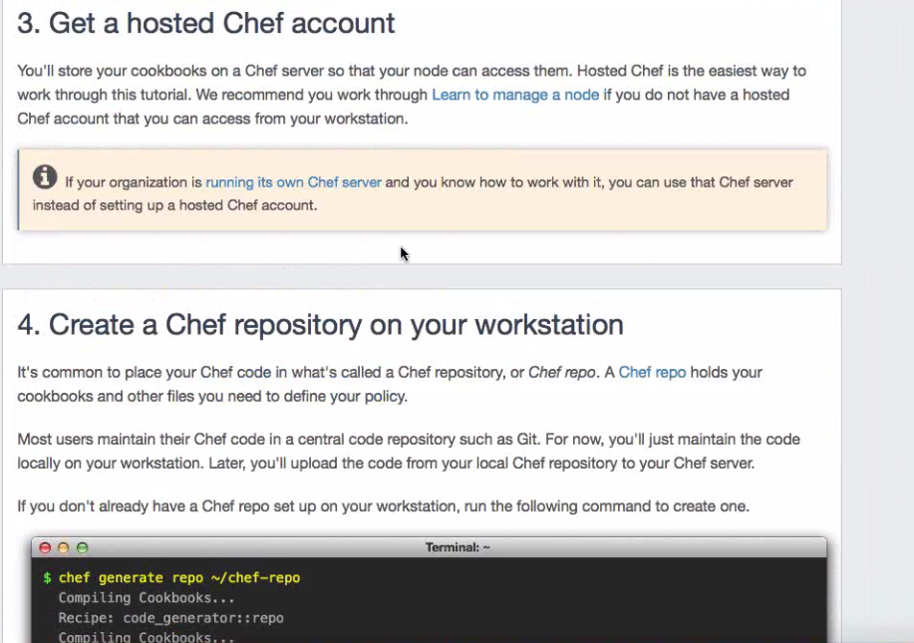

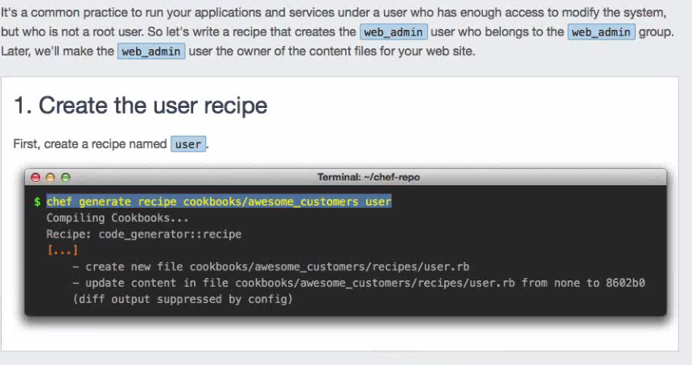

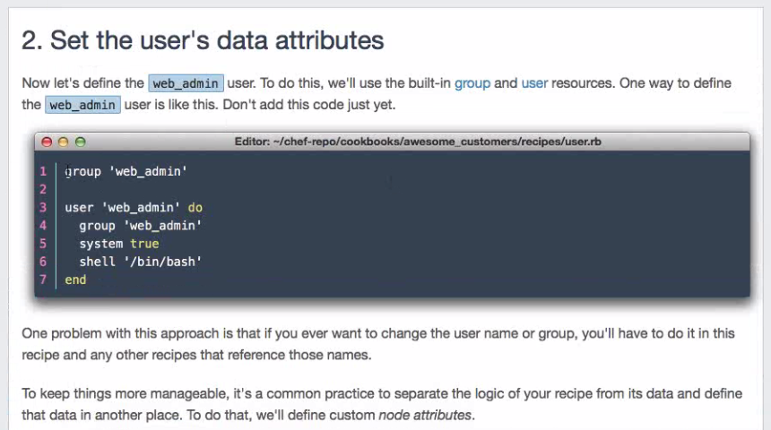

Line1) Creates a group ‘web_admin’ Line2) Creates user ‘web_admin’ under a group ‘web_admin’ and adds him to shell (bin/bash)

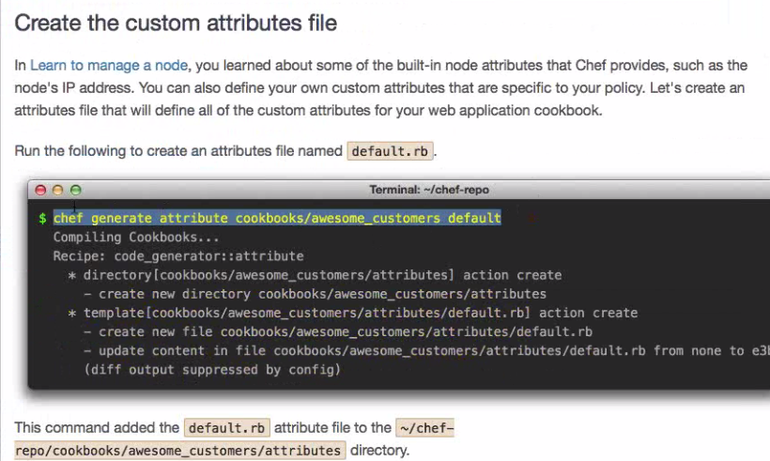

Create a attribute file [variables file, can be used in recipe on the fly]

$Chef generate attribute cookbooks/awesome_customers default



The variables that we declare in recipe under attributes folder can be used in embedded ruby index file under templates folder or any other recipes

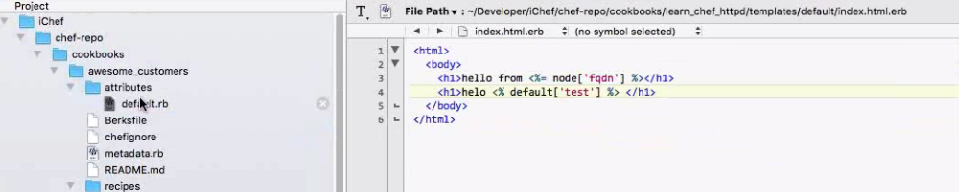

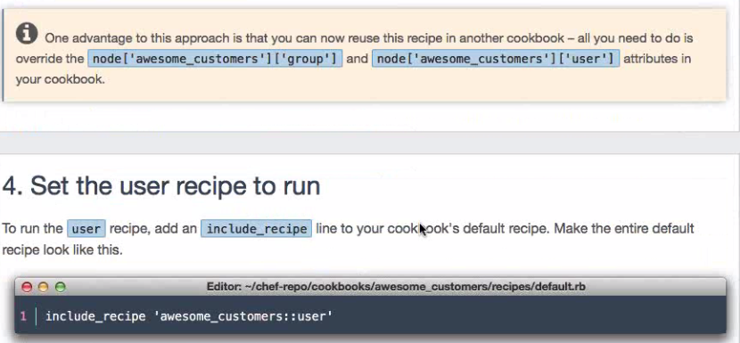

Associate the other recipes created using the statement” include_recipe ‘awesome_customers::user’ “ in the default.rb file.

**Configure Apache**

Reference/Load the cookbooks from Chef Supermarket and use them:

Ex: just append the line “depends ‘httpd’, ‘~>0.2.018’ “ in other recipe to load httpd cookbook.

How to know the latest version of cookbook available in chef server

$knife cookbook site show httpd | grep latest_version

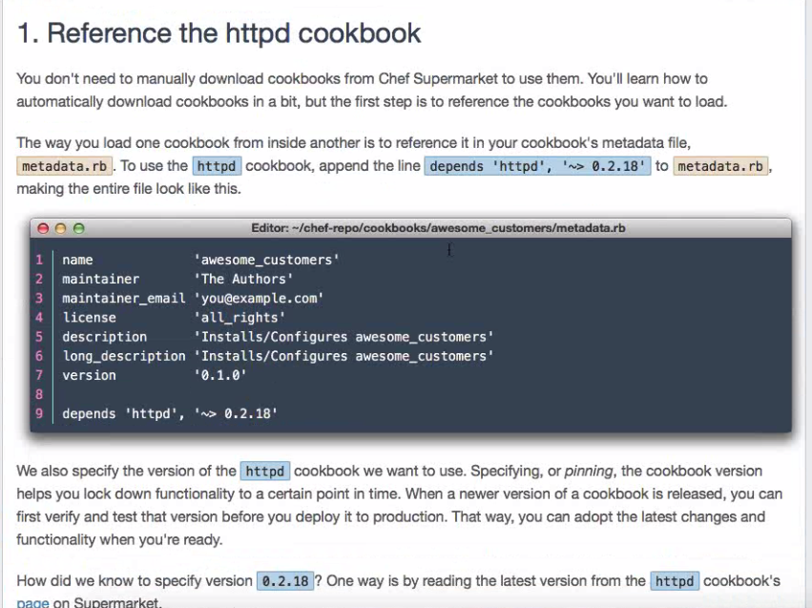

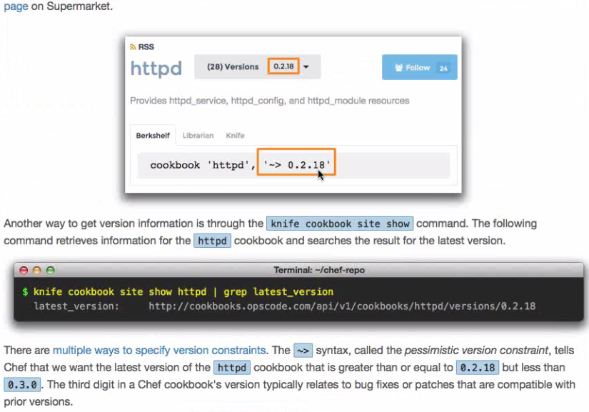

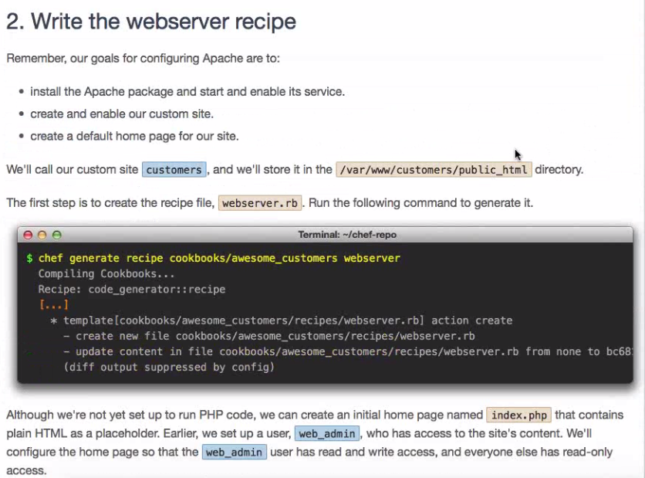

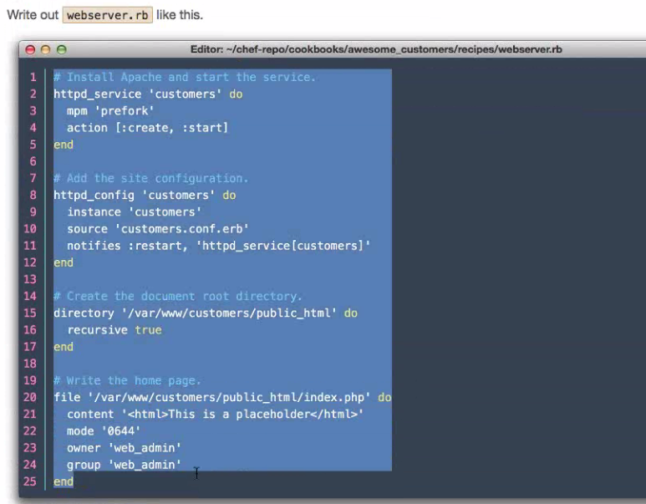

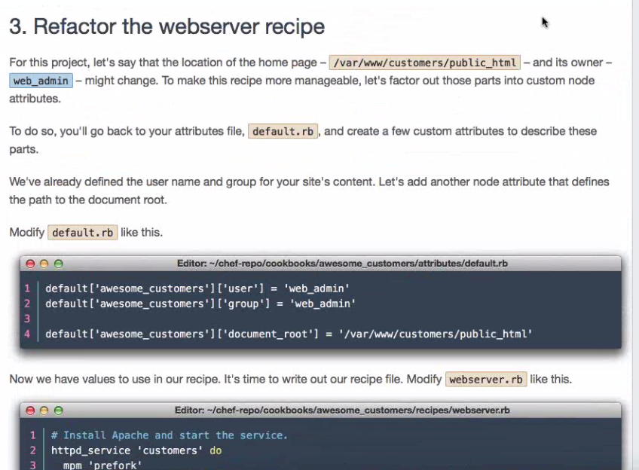

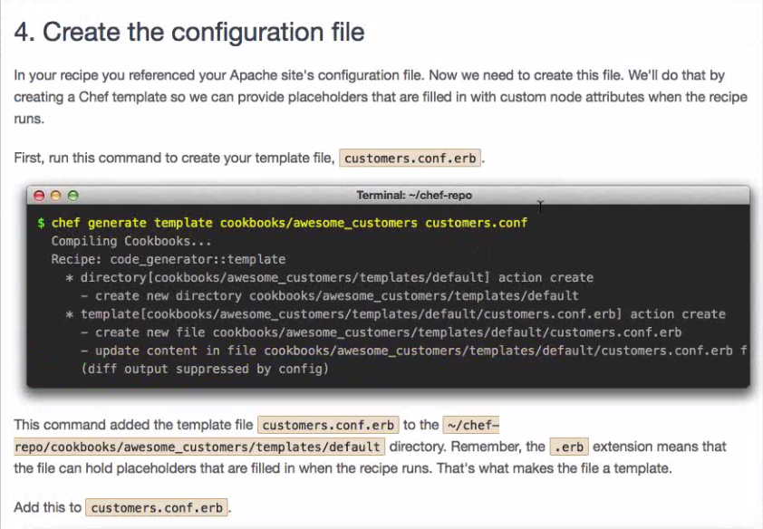

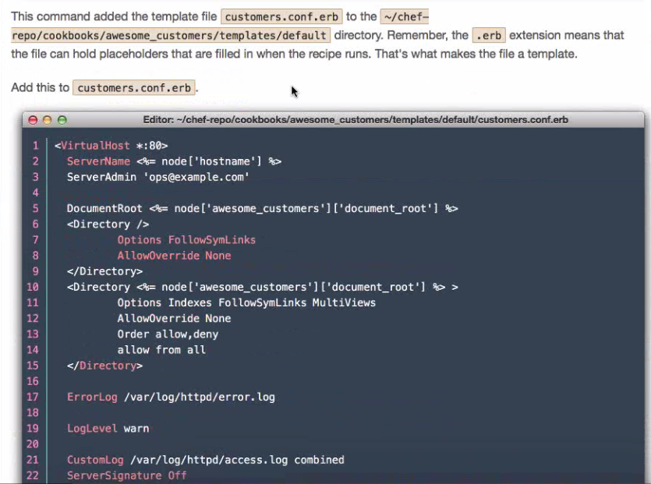

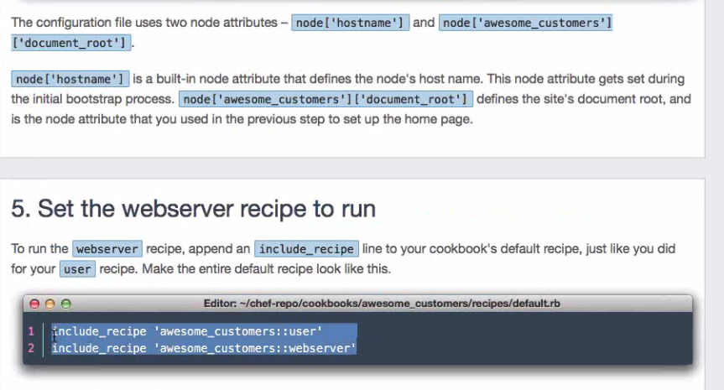



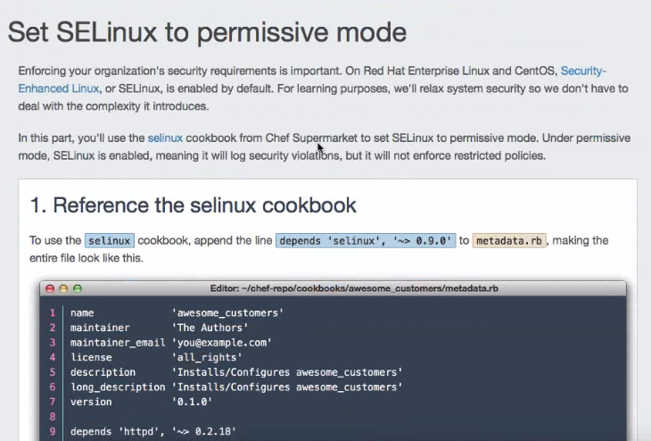

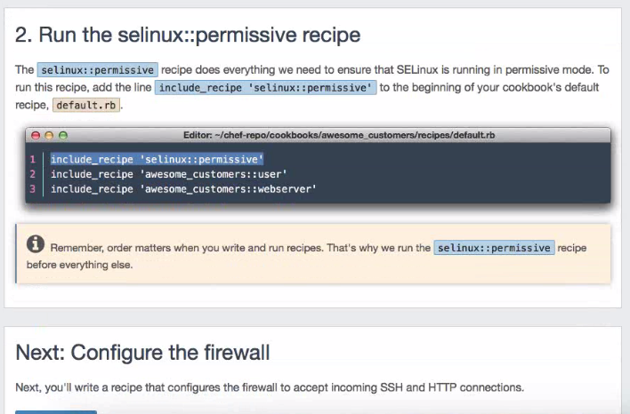

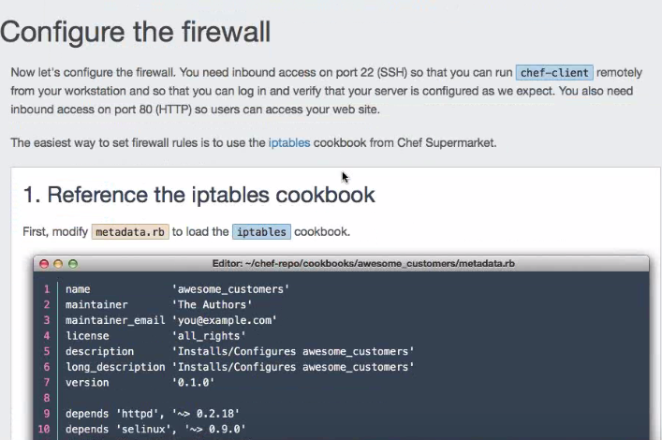

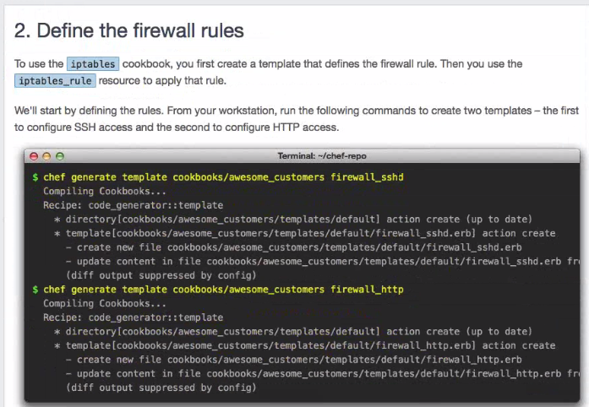

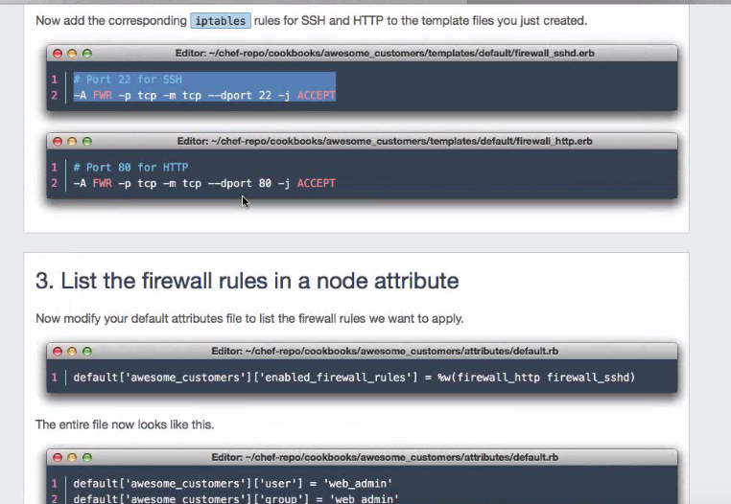

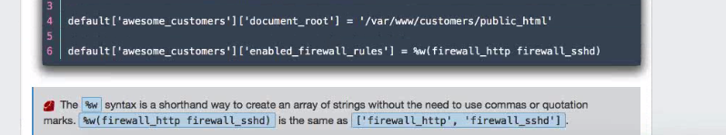 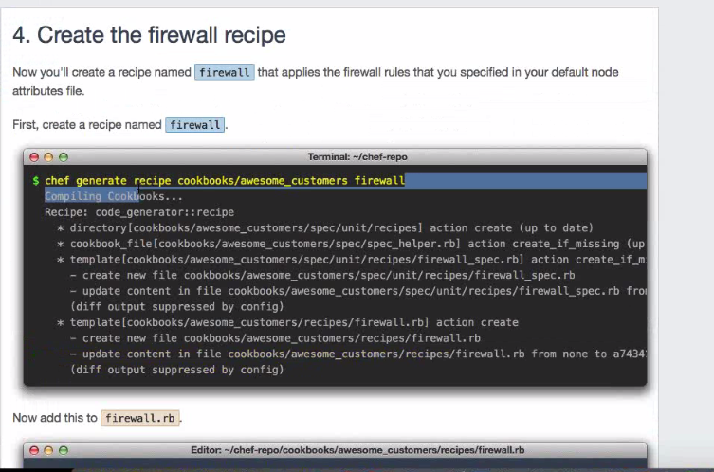

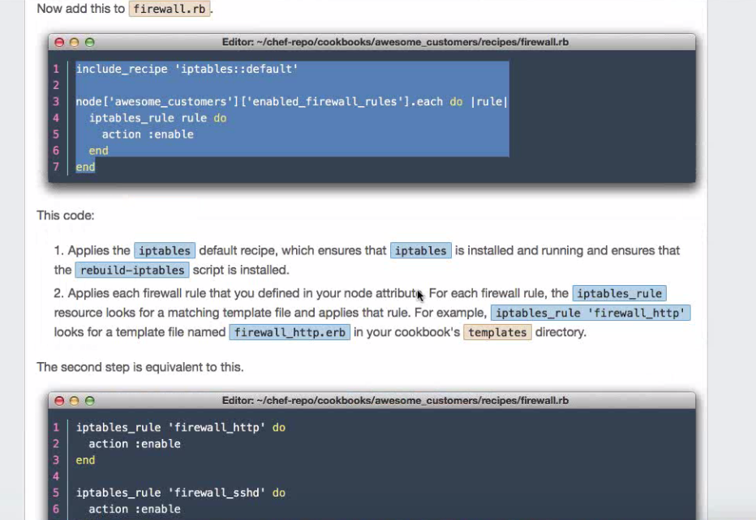

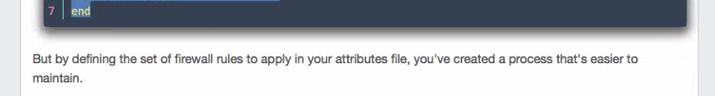

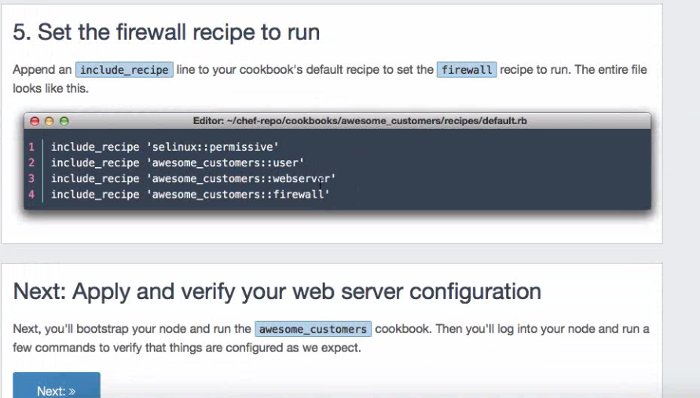

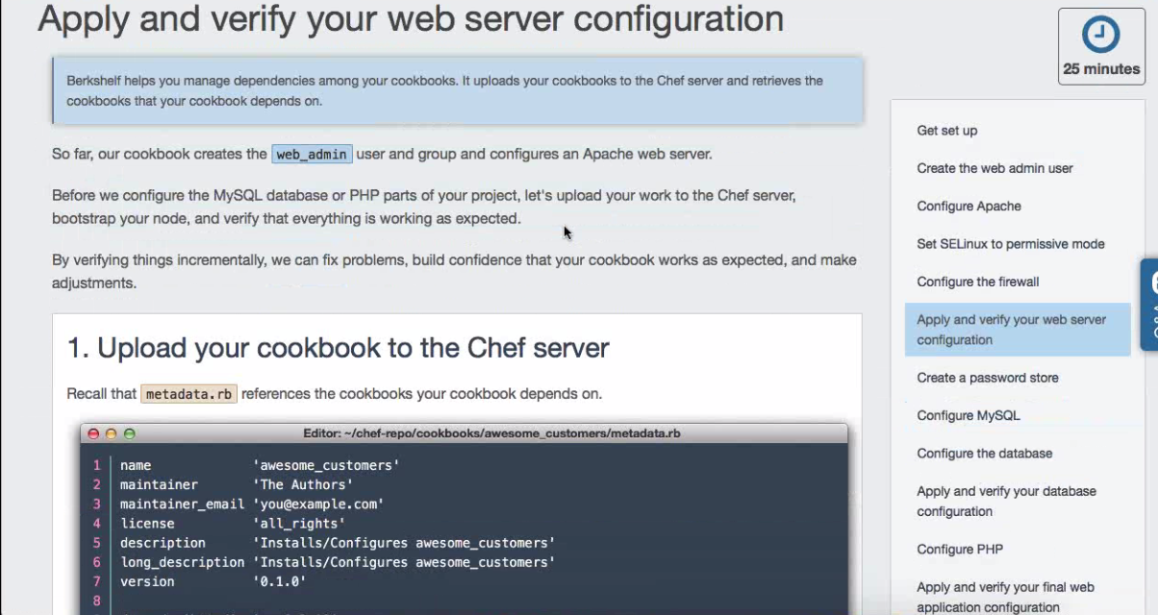

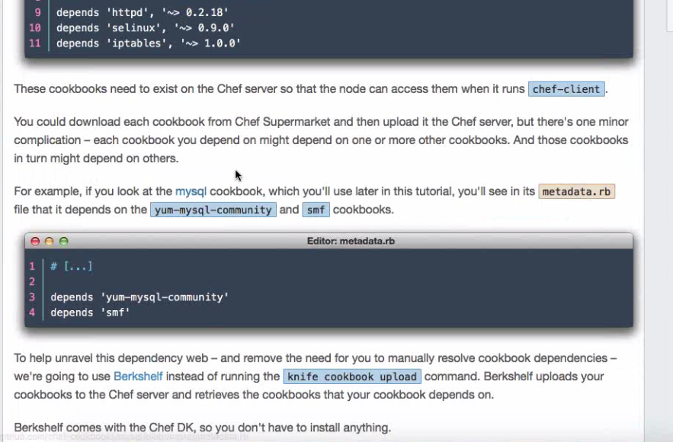

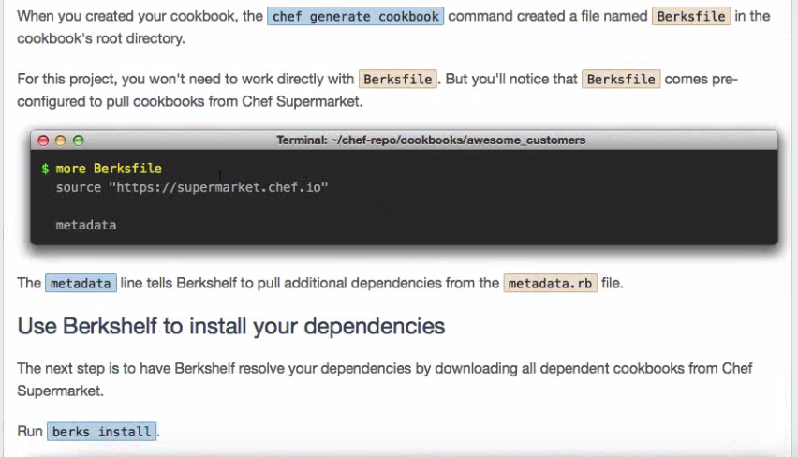

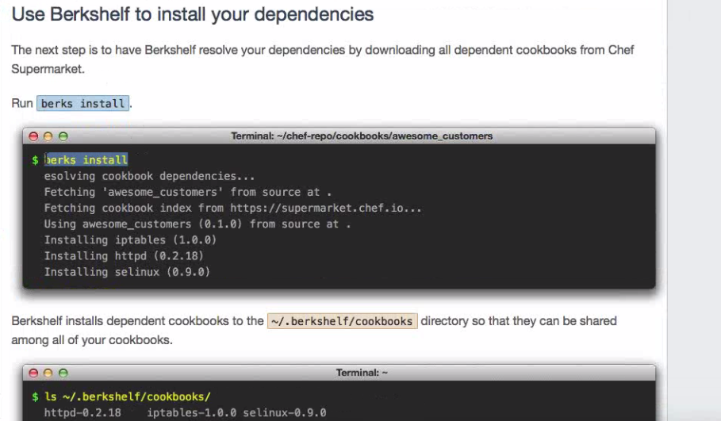

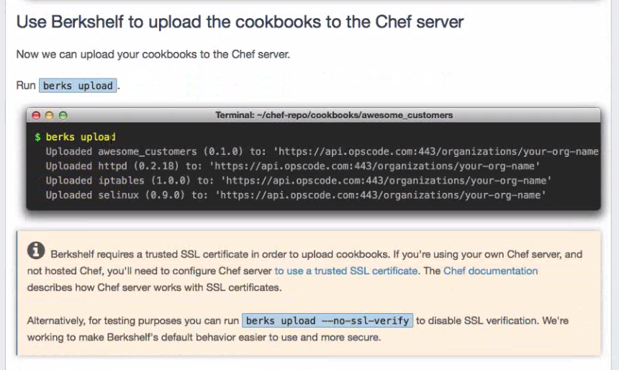

**Manage.chef.io** is the place where our chef server resides.

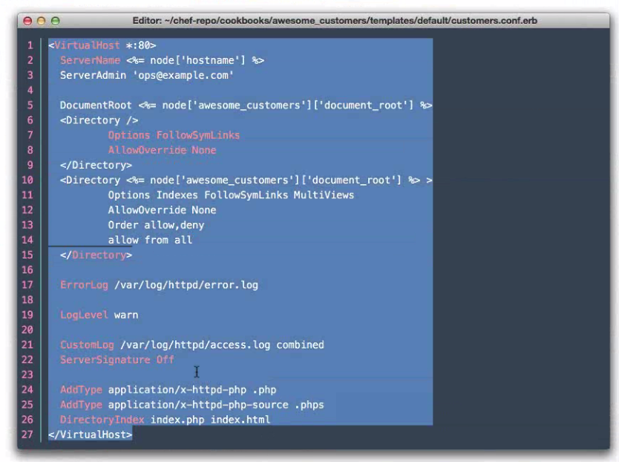

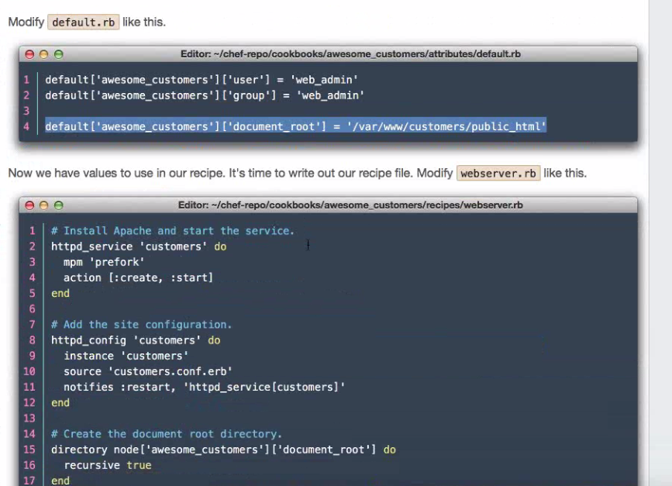

$knife –h [ Lists all the commands available on chef server]

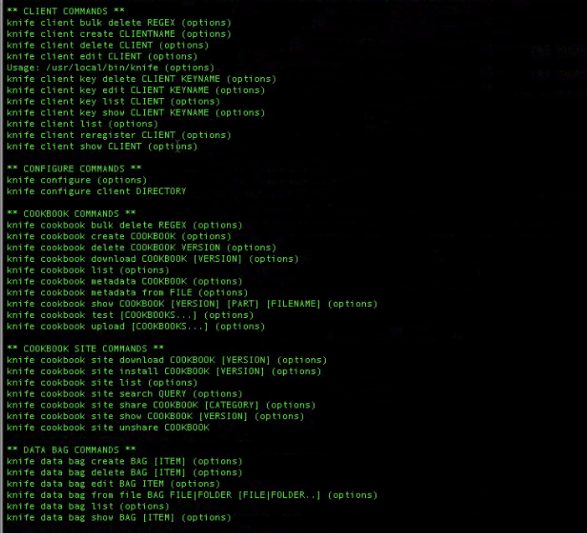

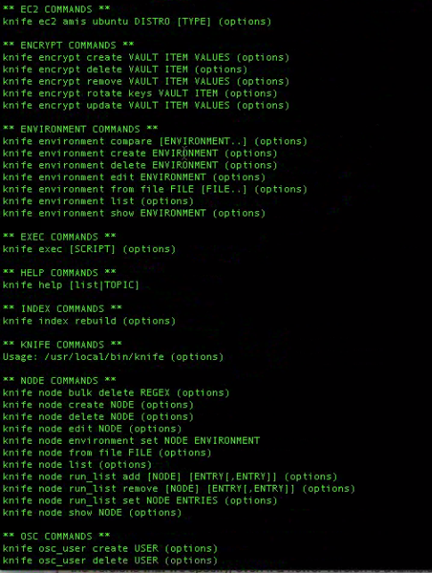

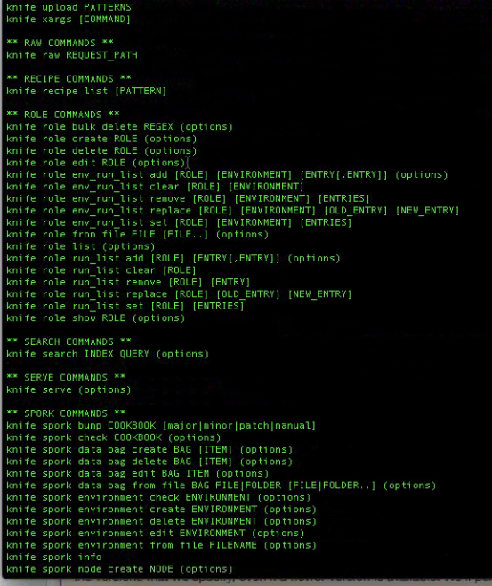

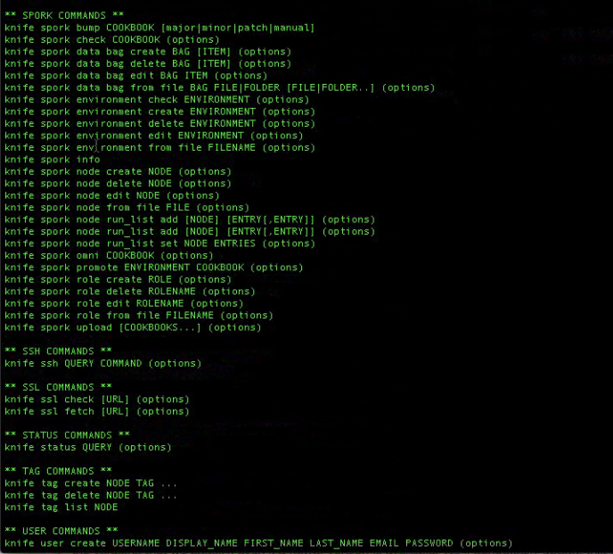

**Chef Solo:**

**chef-solo** is an open source version of the chef-client that allows using cookbooks with nodes without requiring access to a Chef server. It runs locally and requires that a cookbook be on the same physical disk as the node.

chef-solo does not interact with the Chef server. Consequently, node-specific attributes must be located in a JSON file on the target system, a remote location (such as Amazon Simple Storage Service (S3)), or a web server on the local network.

**Cookbook:**

It is a fundamental unit of configuration and policy distribution in chef.

**A** cookbook provides structure to your recipes and enables you to more easily reference external file, it helps to stay Organized.

We create cookbook to make webserver recipe easier.

When we generate a cookbook it will generate a directory structure

This directory structure include Berksfile,Chefignore,metadata.rb,README.md,recipes

The recipe contains a default.rb file where we write our recipe in this default.rb file

We generate a template in the cookbook we have created where this template by default creates index.html.erb file in which we write the content that has to be displayed.

We run the cookbook using chef-client where we specify the run list.

Berksfile is used to specify the dependencies.

We have not used community cookbooks for the webserver cookbook.

Chef turns infrastructure into code. With Chef, you can automate how you build, deploy, and manage your infrastructure. Your infrastructure becomes as versionable, testable, and repeatable as application code.

Chef server stores your recipes as well as other configuration data. The Chef client is installed on each server, virtual machine, container, or networking device you manage—we’ll call these nodes. The client periodically polls Chef Server latest policy and state of your network. If anything on the node is out of date, the client brings it up to date  
<https://docs.chef.io/chef_overview.html>

**Convergense Run**

Convergence is when the configuration management system brings the node into compliance with policy.

In other words, the node is configured based on the roles and recipes in its run list.

Convergence in Chef happens in two phases.

* Compile
* Execute

During the compile phase, these resources (Chef::Resource::Execute) will get arranged in a queue in order of appearance, with their default action, :run. When chef is finished compiling all the recipes (order determined by the node’s run_list), convergence happens.

During convergence, each queue item is iterated through and has it’s provider (in this case, the rather unsurprising Chef::Provider::Execute) applied to it with the action, after primitive predicates are checked — things like not_if and only_if, as we used up there. Presuming the predicates yield a true result and /proc/mouth exists, we will see four echo statements executed, and their output in the chef log.

<http://erik.hollensbe.org/2013/03/16/the-chef-resource-run-queue/>

A **run-list** defines all of the information necessary for Chef to configure a node into the desired state

A **data bag** is a global variable that is stored as JSON data and is accessible from a Chef server. A data bag is indexed for searching and can be loaded by a recipe or accessed during a search.

idempotent: the recipe can run multiple times on the same server and the results will be identical.

Cookbooks are meant to be idempotent (They always brings the system to the same state what ever the original state it was, further if no chages are need recipes executes pretty fast.

Node-Object: Attributes are stored in node object

**DataBags**ares global variables in stored in JSON data and acceable from chef-server

Chef servers can store pieces of data in "**data bags**" as key-value pairs. Chef also supports encryption for the data, using the same RSA asymmetric keypairs that it uses to authenticate clients over the API. The server stores the clients' public keys, and they can be used to encrypt data bag contents, which can then only be decrypted by the appropriate private key.

**The Berkshelf** is a location on your local disk which contains the cookbooks you have installed and their dependencies. By default, The Berkshelf is located at ~/.berkshelf but this can be altered by setting the environment variable BERKSHELF_PATH.

Berkshelf stores every version of a cookbook that you have ever installed. This is the same pattern found with RubyGems where once you have resolved and installed a gem, you will have that gem and it’s dependencies until you delete it.

This central location is not the typical pattern of cookbook storage that you may be used to with Chef. The traditional pattern is to place all of your cookbooks in a directory called cookbooks or site-cookbooks within your [Chef Repository](https://docs.chef.io/chef_repo.html). We do have all of our cookbooks in one central place, it’s just not the Chef Repository and they’re stored within directories named using the convention {name}-{versio

How will chef work?

There are two types which chef works:

**Server-Client Model**

**Chef Solo:**

**Server-client model: explain how there is a chef server and all agents converge themselves to the state prescribed by chef server**

The Chef server acts as a hub of information. Cookbooks and policy settings are uploaded to the Chef server by users from workstation.

The chef-client accesses the Chef server from the node on which it’s installed to get configuration data, perform searches of historical chef-client run data, and then pull down the necessary configuration data.

After the chef-client run is finished, the chef-client uploads updated run data to the Chef server,uploads data generated by audit-mode and generates reporting data.

Chef-client runs on all the servers and keeps in regulartouch in chef server. When there are changes chef updates and aligns the system. Chef-client does most of the work. Each server configures itself.

Each resource is executed in order identified by the run-list and then by order in which each resource is listed in each recipe. Each resource in the resource collection is mapped to a provider. The provider examines the node, and then does the steps necessary to complete the action. And then the next resource is processed. Each action configures a specific part of the system. This process is also referred to as **convergence**.

Chef management console is the user interface for the Chef server. It is used to manage data bags, attributes, run-lists, roles, environments, and cookbooks, and also to configure role-based access for users and groups.

Therefore this distributed approach makes chef most scalable automation platform in the world.Chef will be able to resolve complex dependencies.